Learning Curve Theory Application to a Project and Project Cost Estimation
Student’s Name
Institutional Affiliations

Learning Curve Theory Application to a Project and Project Cost Estimation
Section “A” - Applying the Learning Curve Theory to a Project
Task 1
Learning curve is defined as the rate of a person progress in gaining experience or new skills (Malyusz, 016). The curve as the names suggest show the rate at which an individual progresses over time in relation to the achievement of certain skills. It is an important tool in that it enables one to know the skills acquired at different stages. The learning curve theory therefore states that the effort to complete a task should take less time and effort as the work is being done over time (Hattingh, Van Waveren & Chan, 2019). The theory seeks to elaborate the fact that the undertaking of task should be done in such a manner that does not consume much time and effort. The people undertaking the project need to ensure that they formulate appropriate strategies that will ensure that the project completes using less time. The learning curve theory is useful in project management as it is applied in the estimation of cost and schedule. The project managers use the learning curve theory to estimate the costs that will be incurred in the project at different stages and the time that the project will be estimated to take.
This is very important as the project managers need to be aware of the amount of funding to be used from completion of the project and also the time period in which they are required to have completed and handed over the deliverable. Through the learning curve theory, project managers are able to ascertain the costs involved at each stage and the tasks that are performed. They are able to know the time that is taken by each of the tasks and thus be able to estimate the overall time. The advantage of knowing this is that the project owners can be briefed about the progress of the project based on the calculations done and thus be able to ascertain if the project is on track or not.
Task 2
As the project manager, I will apply the concept of learning curve theory to the project that I will be undertaking. This will be done through the identification of different tasks that will be required in the project. The establishment of the task will lead to the calculation of the costs to be incurred for each and every stage. This is important as I will be able to know the total cost required per task which will then be aggregated to come up with the total costs for the whole project. The learning curve theory will also be useful to me in estimating the time that I will need to complete the project. Project deadlines are very important as they prevent the team members from being relaxed. They know they have to operate within a certain time frame and thus they will enhance their performance. As the project manager, I will therefore apply the learning curve theory to come up with the time frame in which the project will be expected to end. Therefore, the learning curve theory will be a useful tool as I undertake the project to completion. Most importantly, the learning curve theory will be vey vital in the estimation of the project cost through calculation of iterations of the project because the learning curve theory consideration and calculations are vital to project estimation and iteration (Malyusz, 2016)
EXERCISE: Using the concept of Learning Curves for Estimating consider the following scenario and respond to each question (all work should be shown in your Word document):

Suppose that you are the estimator who is assigning costs to a major project to be undertaken this year by your firm, Acme Software Developers. One particular software development process involves many labor-hours, but the work is highly redundant. You anticipate a total of 100,000 labor-hours to complete the first iteration of the software development process and a learning curve rate of 80%. Assume you are going to use the cumulative average time in your calculations to determine the time it takes for each iteration. You are attempting to estimate the cost of the tenth iteration of this repetitive process.

Solution

Based on this information and a standard learning curve coefficient of .596, given the learning rate of 80% with 100,000 labor-hours. Using the formula,
T_{N} = T₁C
Where T_{N} = Time needed to produce the N^{th} unit
T₁ = Time needed to produce the first unit
C = Learning curve coefficient

Therefore, a $60 per hour labor rate, the budget would be expected to be:

T₁₀ = T₁C
= (100,000) (.214)
= 21,400 hours

T₂₀ = T1C
= (100,000) (.150)
= 15,000 hours

A. The cost of the tenth iteration?
To find the cost, multiply the hours by the hourly rate:

10th iteration: (21,400 hours) ($60 per hour) = $1,284,000
B. The cost of the twentieth iteration?

20th iteration: (15,000 hours) ($60 per hour) = $900,000

Section “B” - Assignment # 5

Plan for delivery schedule, cost of a Project & ROI:

For a company engaged in design and delivery of a nursing home in Maryland, the following tasks (that are Not in a proper order), with corresponding duration and cost for each task are envisaged for the plan. Please fill the attached table by listing all the necessary tasks involved in proper sequence, showing start & finish of each task and associated costs, then find the total project proposed cost/value/price to client by including 12% for overhead, and 15% for profits. Derive the cash-flow diagram, and extrapolate B.E., and subsequently suggest the best ROI for the project:

Locate and survey the land 4 weeks $25,000
Approvals 1 week ------
Select Contractors 3 week $5000
Design details and develop plan 20 weeks $68,000
Grading of the land, Water & Sewer lines 5 weeks $45,000
Install Security System 3 week scattered $18,000
Build Frame structure & walls 8 weeks $90,000
Install Windows & Doors 4 weeks $35,000
Install Airconditiong System 3 weeks $35,000
Build Foundations 6 weeks $60,000
Install Electrical lines, Plumbing 4 weeks $38,000
Flooring 3 week $35,000
Carpeting & Clean up 2 week $20,000
Painting 3 week $35,000

Solution
Location and surveying of the land 4 weeks $25,000
Land title and processing- $10000
Elevations- $2500
Markers- $1500.
Labor- $6000
Soil survey proceesing and report- $5000
Approvals 1 week ------
Design details and develop plan 20 weeks $68,000
Location, boundary, contour and land maps labor -$32,000
Design - $10700
Direct labor overhead- $12800
Subcontractor- $10000
Subcontract hanlding fees (5%)- $2500

Select Contractors 3 week $5000
Recruitment of contractors and associated works- $5,000
Grading of the land, Water & Sewer lines 5 weeks $45,000
Land Grading- $8,,000
Water line- $11,000
Sewer line- 13,000
Labor-$12,000
Build Foundations 6 weeks $60,000
- Site clearing and preparation
- Earthwork -includes excavation, filling, dressing, dewatering, etc.
- Concrete work - includes plain and reinforced concrete works, prefabricated concrete works, formwork for concrete structures, etc.

Install Electrical lines, Plumbing 4 weeks $38,000
Electrical Wiring Plan -$11,000
Plumbing plan-$9,000
Installation plans & costs- $7,000
Reinforcement costs- $11,000
Build Frame structure & walls 8 weeks $90,000
- Concrete work - includes plain and reinforced concrete works, prefabricated concrete works, formwork for concrete structures, etc. - $20,000
- Brickwork - includes brickwork in foundation and plinth, brickwork in superstructures, etc. -$7,000
- Stonework - includes stone work for bed or wave protection and in structures, etc. -$ 12, 000
- Woodwork- $ 9,000
- Steelwork - $ 11,000
- Roofing -$15,000
- Water supply and sanitary works $9,000
- Miscellaneous -$5,000
- Finishing- $5,000

Painting 3 week $35,000
Preparation- $8,000
Paint Application- $ 12, 000
Colors- $9,000
Touch Up- $6,000
Install Windows & Doors 4 weeks $35,000
Doors- $14,000
Windows-$9,000
Installations works- $12,000
Flooring 3 week $35,000
Flooring & Sanding materials- $27, 000
Flooring works- $8,000
Install Airconditiong System 3 weeks $35,000
Airconditioning systems- $28,000
Installation works- $ 7,000
Install Security System 3 week scattered $18,000
CCTV Cameras- $8,000
Alarms & Sensors- $6,000
Installation works - $ 4,000
Carpeting & Clean up 2 week $20,000
Carpeting works- $11,000
Cleaning works- $9,000

Duration | 65 weeks
Penalty for Late Completion | $800 per day
Bonus for Early Completion | $0 per day
Report Format | Traditional CMG form
Frequency of Progress Reports | Weekly
Conform to Pending Pipeline Marking Legislation | Yes
Contract Type | Flat Fee
Total Project Cost/Amount of Flat Fee | $509,000
Percentage of Profit | Not applicable
Overhead Cost (15%) | $76,350
Penalty for Late Starting Date | $1,000 per day

Cashflow Diagram for the Project with an Extrapolated B.E
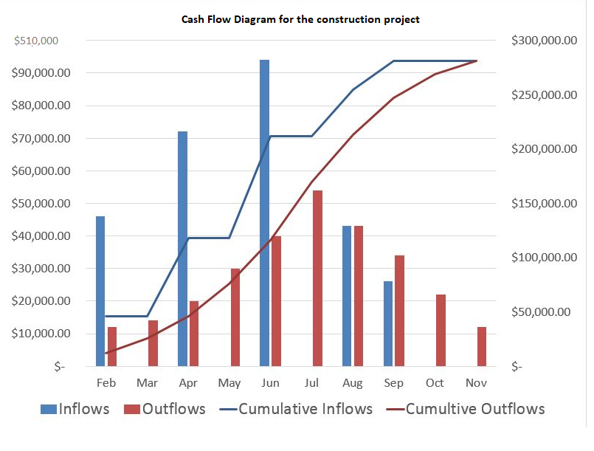

Assessment of this project cash flow comprise great benefits. The cash flow diagram is among the important elements of financial analysis prior to the commencement of and over the course of a project. This analysis can help analyze excessive costs and overruns by comparing the budgeted (i.e., time-phased estimates) cost of performing the changed work with the sums of money originally. needed to make progress according to the plans. This assessment can help identify the adverse effect of the change on the resource costs needed over.

Best ROI for Maryland Nursing Home
Calculating the payback period
This is possible by creating a list of all cash flows for the project, either incoming or outgoing, from the start of the project. Since this project will spend cash while executing, and generate money once the benefits are delivered. Listing of the incoming and outgoing money into the future in time sequence, until the two are equal; at this point in time the original investment has been paid back. The time from the start of the project until payback is achieved is the “payback period.” A TVM-adjusted cash flows can be used to get a more sophisticated view of payback period, considering the cost of financing.

References
Hattingh, E., Van Waveren, C. C., & Chan, K. Y. (2019). A learning curve theory perspective on projects. Ranking the key determinants to improve project efficiency. South African Journal of Industrial Engineering, 30(1), 37-53.
Malyusz, L. (2016). Learning curve effect on project scheduling. Procedia engineering, 164, 90-97.

